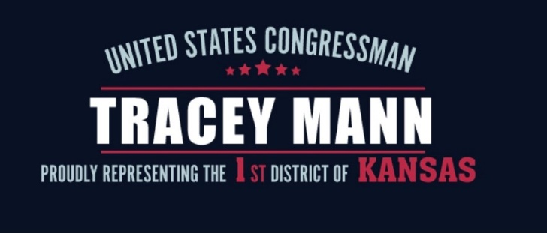
Immigration Privacy Release Form

Petitioner/Applicant:
Name:
Date of Birth:
Alien Number (if any):
Country of Birth:

Beneficiary:
Name:
Date of Birth:
Alien Number (if any):
Country of Birth:

USCIS receipt or tracking number:
Place of Filing:
Form Type:

Please describe what you need assistance with and attach any beneficial information:

Have you contacted any other congressional office about this matter? If so, which office?

The beneficiary should fill out the information below.

I certify, under penalty of perjury, that I provided or authorized all of the information in this privacy release and any document submitted with it; I reviewed and understand all the information contained in my privacy release and submitted with it; and all of this information complete, true, and correct.

I (print name) , authorize USCIS to release information contained in my USCIS records as relevant to checking my case status, and to the extent permitted by law, to U.S. Congressman Tracey Mann and the Member’s staff.

Signature (with ink):

Date:

Address:

City/State/Zip:

Phone:

Email:

Please return this form to our constituent services director at Martha.Mendoza@mail.house.gov.

